



**Module Code & Module Title**

**CS6P05 Final Year Project**

**Assessment Weightage & Type**

**5% FYP Proposal**

**Semester**

**2024 Autumn**

**PROJECT TITLE: AI-EMS(Employee Management System)**

**Student Name: Apil Thapa**

**London Met ID: 22067753**

**College ID: np01cp4a220164**

**Internal Supervisor: Mr. Alish Kc**

**External Supervisor: Mr. Samrat Thapa**

**Assignment Due Date:**

**Assignment Submission Date:**

**Word Count: 1850 words**

*I confirm that I understand my coursework needs to be submitted online via Google Classroom under the relevant module page before the deadline in order for my assignment to be accepted and marked. I am fully aware that late submissions will be treated as non-submission and a mark of zero will be awarded.*

ACKNOWLEDGEMENTS:

I would like to express my heartfelt gratitude to the honorable faculty of Islington for providing me with guidance and support in my academic career. My research skills and technical knowledge have improved significantly all credit to our college for creating such a supportive learning environment. Also, I would like to thank my supervisors, Mr. Alish KC and Mr. Samrat Thapa for their valuable feedback and mentorship. It was their faith in my expertise and timely suggestions which guided me through the challenges along the way and propelled this initiative to success. Last, but not the least, I am deeply grateful to all members of Islington College, you guys really motivated me and assisted anytime where needed which helped me a lot in my life.

ABSTRACT :

This Employee Management System is designed to simplify and improve management level of employees. It combines modern tools with AI for meeting the things which are needed in today's workplaces. The system makes it easier to handle tasks, interact with posts, and with documents using AI features. Employees can use the system’s simple interface to update their work, monitor tasks, and collaborate with their team. The EMS also includes tools that use AI to answer questions about documents or summarize information, which ultimately saves time and helps teams to make better decisions. For improving teamwork the system offers real-time communication features which are also secure, with role-based access controls and strong data protection. For scalability, the system is hosted in the cloud using Kubernetes, making it reliable as the organization grows. By using this AI powered system, companies can improve communication, and ensure the system adapts to future needs. It is a complete solution that combines ease of use with advanced technology to support modern employee management.

1. INTRODUCTION:

The Ai based Employee Management System is the best tool for modern workplaces to optimize work processes and glean better productivity. It is applicable in different types of sectors to handle office work, communicate better, and structured document processing with Ai features. Teams using this system are able to stay organized, fulfill deadlines, and collaborate effectively in both small and large firms.

The system simplifies task management by allowing managers to assign and monitor tasks while enabling employees to update progress and submit completed work efficiently. It has features like handling documents and summarizing it in understandable form, also it allows you to query the documents using prompts. Also, It allows Real time communications, each employee and manager personalized dashboard and feedback sentiments analysis and announcement mechanisms which is helpful for engagement and alignment to teams. Also, this system will be designed with security and scalability features which in future will be adapting to future challenges with ease.

# 1.1 PROBLEM STATEMENT:

Our Employee Management System overcomes traditional practices still common in Nepal, where managers assume employees work only for money. While some organizations are improving, many still lag behind. Regardless of some public and government organization, most of the private corporate houses started implementing good employee management practices in Nepal.()

Our system focuses on modern, AI-driven tools to boost engagement, collaboration, and productivity, breaking away from outdated approaches.

* Ineffective Task Management: In Nepal and foreign countries, organizations often resort to manual assignment and tracking of tasks, which results in missed deadlines and overall low productivity.
* Lack of communication: For remote employees staying connected, getting timely updates and collaborating effectively often come out as major challenges in Nepal's rural areas, and globally in remote working setups.
* Time Consuming Document Handling: Querying from documents also summarizing large documents manually slows decision making and increases workload.
* Lack of Employee Engagement: There are very certain or limited tools in which employees can share their feedback and manager announce updates.
* Data Security Concerns: Today’s world cyber threats are growing, many organizations are struggling to protect sensitive employee and operational data.

**1.2 PROJECT AS A SOLUTION:**

The above challenges can be solved by EMS, which has number of web-based and AI powered features regarding the above challenges, as listed below:

* **Employee Registration and Approval:** Employees first register using form and then managers review all new hires and he can approve or reject applicants, and assign approved employees to departments and their position.
* **PIN Based Activation:** Once a manager assigns a department and position, an PIN is sent to the employee. The employee must enter a PIN to activate their account and login into the system.
* **Task Automation:** Manager assigns tasks to employees and employees can see their own task in their dashboards.
* **Real-Time Communication:** It enables communication with team members in the system.
* **AI Document Tools:** It allows quickly querying and summarizing contents from documents.
* **Feedback and Engagement:** it collects employee feedback and shares updates to improve morale.
* **Secure Data Management:** Protects sensitive information with proper security and role-based access.

2. AIMS AND OBJECTIVES:

2.1 AIMS:

This system is designed to automate and improve employee management processes through AI powered tools. It essentially streamlines task assignment and post interaction, enhances communication, automates document handling, and increases employee engagement. Ensuring practicality, productivity, and smooth operations in contemporary workplaces, the system offers features such as registered verification, PIN based activation, real-time collaboration, and smart document summarization.

2.2 OBJECTIVES:

1. To Implement PIN registration features on which employees register with their details and after manager approval PIN code is sent to employee email for account activation and login.

2. To Implement the feature for creating posts and allowing interactions in those posts such as likes and comments.

3. To Develop a portal for creating , assigning the tasks to an employee and employee also can see all assigned tasks in his/her portal.

4. To Develop a feature that allows employees to generate meeting slide presentations.

5. To Integrate Real time messaging system for engaging and collaborating with each other within teams across departments.

6. To Implement a chatbot to assist employees and managers with queries, and support related to tasks, policies, and other general information.

7. To Implement the advanced Agentic RAG (Retrieval-Augmented Generation) system, which allows employees to query their documents.

8. To Implement the LLM with llama Index and Langchain for generating the summary of the notebook uploaded by the employees.

9. To Develop a system for employees to submit their feedback anonymously and managers to publish announcements.

# 3. EXPECTED OUTCOMES AND DELIVERIES:

After completing this project the system delivers all innovative and unique features aimed at enhancing employee management systems. Below here is breakdown for outcomes and deleveries:

## 3.1 EXPECTED OUTCOMES:

**Core Features:**

* **Interactive Post System:** Employees can create posts which can be seen directly by managers as well as department people.
* **Efficient Task Management:** Manager can assign tasks to all employees and employees can directly see those tasks in his / her dashboard.
* **Automated Meeting slide Generation:** Tools for Employee to generate meeting slides through text content.
* **Document Querying and summarizing:** AI tools for querying, and summarizing documents.

**Side Features:**

* **Sentiment analysis of feedback:** Employee submits feedback which manager can read and also generate sentiments by all those feedbacks.
* **Automated attendance using facial recognition:** Employee attendance is carried out using facial recognition where employees need to show face for having attendence.
* **Chatbot Assistance:** An AI powered chatbot which assists both manager and employee with system related information.
* Added AI tools for content and plagiarism detection to ensure originality and quality in employee documents and reports.

## 3.2 DELIVERIES:

1. Functional Prototype

A fully functional EMS prototype which showcases core and side features:

* Post Creation and Engagement
* Submission and management of tasks.
* Services for feedback and announcement
* AI tools for creating slides.

1. User Guides

Comprehensive user guides detailing:

1. Setup, Configuration and Usage of Employee Management System
2. Tutorials for employees and managers to effectively utilize its features for task management, collaboration, and productivity enhancement.

3. Technical Documentation

A comprehensive technical specification that includes:

1. System architecture and component description.
2. Data models and flow diagrams.
3. Deployment and maintenance guide.

# 4. RISKS, THREATS AND CONTINGENCY PLANS:

| **Risk Area** | **Risks** | Contingency Plans | Threats |
| --- | --- | --- | --- |
| System Downtime/Overload | Heavy resource consumption by AI tools (e.g., facial recognition, sentiment analysis) leading to system lag. | Use scalable cloud platforms (e.g., AWS, Azure).  Apply model quantization (e.g., **INT8, FP16,GGUF**). | Frequent downtime disrupts employee workflows.  Reduced confidence in system reliability. |
| AI Model Bias | Limited or skewed training data results in biased outputs for sentiment analysis or chatbot responses.  Training a transformer model on **1 million rows** for **1000** epochs can take **24,000** hours and cost between **$12,624** and **$73,440.** | Train models on diverse datasets.  Regularly update models and validate outputs with domain experts. | Employee mistrust in AI predictions.  Compliance and ethical concerns. |
| Internet Stability | Cloud-dependent operations (e.g., model training, inference) interrupted by unstable connectivity. | Enable autosave checkpoints during operations.  Configure failover mechanisms for critical workflows. | Delays in task assignment and processing.  Potential data loss or incomplete records. |
| Integration Challenges | Lag between AI tools and real-time web components due to large model sizes or poor optimization. | Pre-test system performance.  Use lightweight models.  - Opt for asynchronous data processing. | Reduced efficiency in real-time task updates.  User dissatisfaction with slow responses. |
| Attendance System Errors | Facial recognition inaccuracies lead to attendance disputes or missed logs. | Use robust, high-accuracy models.  Allow manual overrides for unrecognized cases.  Periodically test the system. | Disputed records leading to employee dissatisfaction.  Reduced trust in the attendance system. |
| Sentiment Analysis Inaccuracy | Misinterpreted feedback sentiments result in flawed managerial decisions. | Validate results manually for critical feedback.  Train models on domain-specific feedback datasets. | Damaged employee-manager relationships.  Loss of credibility in the feedback system. |
| Chatbot Assistance Errors | Chatbot provides irrelevant or incorrect responses, affecting productivity. | Continuously update the chatbot knowledge base.  Include an escalation option for human assistance. | Employee reliance on faulty responses.  Reduced overall system efficiency. |

# 5. METHODOLOGY:

Agile Scrum is a flexible and collaborative approach to managing software development projects. It focuses on breaking down work into small, manageable chunks called sprints, which are typically 1 to 4 weeks long. During each sprint, a specific part of the project is completed, and the team can gather feedback from stakeholders to make improvements for the next sprint. This makes it easy to adjust the project as needs change, which is ideal for developing an employee management system where requirements might evolve over time.

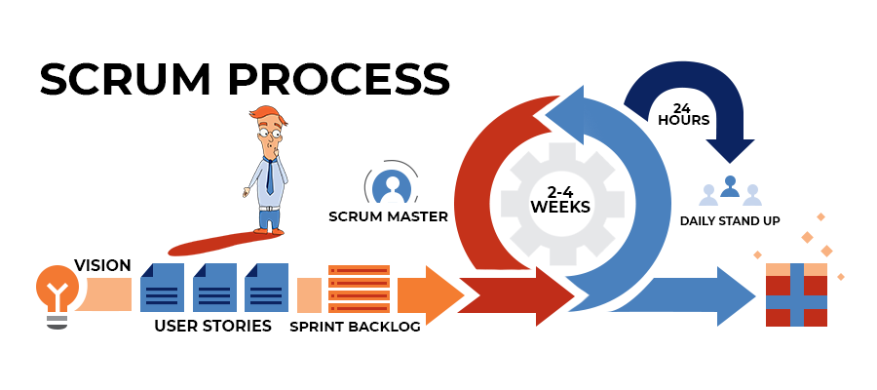

**Key Elements:**

#### **Roles**

* **Product Owner**: Defines vision, managing backlog and prioritizing features.
* **Scrum Master**: Facilitates Scrum and which ensures principles.
* **Development Team**: Cross-functional, self-organizing, the team delivers increment.

#### **Artifacts**

* **Product Backlog:** Product features, requirements in a prioritized manner.
* **Sprint Backlog:** All tasks selected for the current Sprint
* **Increment:** Potentially shippable, usable, value-adding product.

#### **Ceremonies**

* **Sprint Planning:** Defining Sprint Goal, choosing tasks.
* **Daily Scrum:** Daily 15-minute Meeting to discuss what was done, what is being worked on, and what impediments obstructed it.
* **Sprint Review:** Show work done, collect feedback.
* **Sprint Retrospective:** Reflect and adjust processes.
* **Duration:** Typically 2-4 weeks for product increments.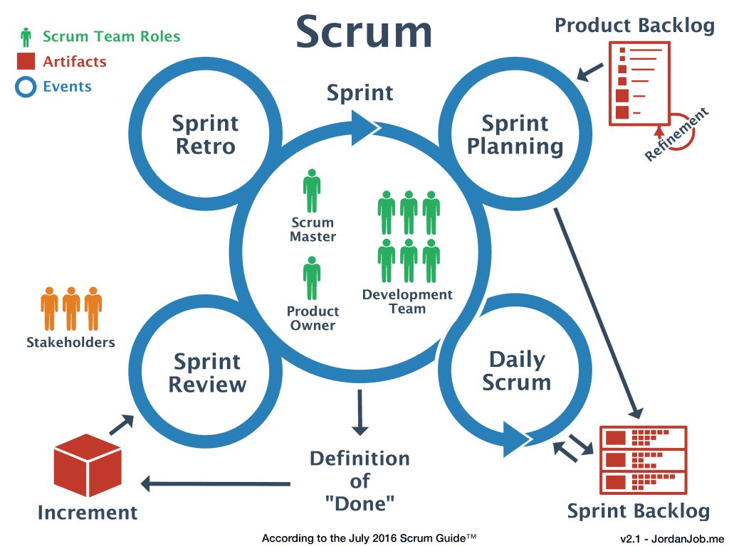

**Importance of choosing Agile scrum Framework for my AI based EMS project is:**

* **Flexibility in AI Development and Design:** Iterative approach in scrum methodology provides flexibility for incremental updates which we are bringing to AI model development and architecture whenever necessary.

* **Rapid Development and Feedback Cycle:** Developers sit side-by-side with AI people and end-users enabling them to quickly modify features like chatbot assistance or document queries.

* **Accelerated Prototyping and Testing:** Sprint cycles allows to quickly build and test AI parts, such as task features or even an automated generator of meeting slides to make sure it works properly.

* **Continuous Improvement:** Regular sprint reviews allow refining the AI system’s design and functionality, ensuring optimal performance and user satisfaction.

* **Web and AI Integration:** Scrum enables smooth integration of AI models with web components (e.g., automated meeting slides, task management), ensuring real-time functionality and minimal lag.

# 6. REQUIREMENTS:

6.1 HARDWARE REQUIREMENTS:

| Component | Details |
| --- | --- |
| Development Machine | Model: LAPTOP OR PC ABOVE 512 GB SSD WITH 3070 GPU  Processor: Intel Core i7 GEN 8 above  RAM: 16 GB  Storage: 1 TB SSD |
| Additional Hardware | External SSDs for backups, storing datasets, and models |

6.2 SOFTWARE REQUIREMENTS

| Category | Details |
| --- | --- |
| Frontend Development | HTML, CSS, Bootstrap  JavaScript: For adding interactivity and dynamic functionality to the frontend. |
| Backend and API Development | Python (Fast API): Used for developing RESTful APIs with high performance, scalability, and integration with AI/ML models and databases. |
| LLM Models & Frameworks | Pre-trained models, fine-tuned for tasks like document handling and chatbot interface.  Hugging Face Transformers or PyTorch |
| Optional Models for NLP | BiLSTM + Attention: Suitable for sequence-to-sequence tasks, offering a robust understanding of sequential data.  GRU + Attention: Efficient for time-series and NLP tasks, with lower computational overhead compared to LSTMs.  BiGRU + Attention: Combines bidirectional GRUs with attention mechanisms for improved performance in complex NLP tasks. |
| Containerization | Docker: For containerizing APIs, models, and services.  Kubernetes: For managing and scaling containerized applications. |
| Cloud Services (AWS) | EC2: For scalable compute resources.  S3: For storing datasets, model checkpoints, logs, and backups.  EKS: For deploying Kubernetes clusters.  RDS: For managing relational databases (PostgreSQL/MySQL).  Lambda Functions: For serverless backend task execution. |
| Data Science Libraries | Pandas, NumPy, Scikit-Learn: For data preprocessing and manipulation |
| Additional Tools | CI/CD: GitHub Actions or Jenkins for continuous integration and delivery.  API Testing: Postman or curl for testing API endpoints. |

6.3 ACCESS TO RESOURCES:

| RESOURCE | Details |
| --- | --- |
| Custom Datasets | Domain-specific datasets for LLM fine-tuning. |
| Journals & Publications | Access to recent AI and ML research articles, papers for aligning with latest market trends. |
| IT & Cloud Infrastructure | AWS (or other cloud providers) for deployment, management, and system integration. |
| Additional Tools | Development aids such as CI/CD pipelines and API testing tools based on project needs. |

7. WBS 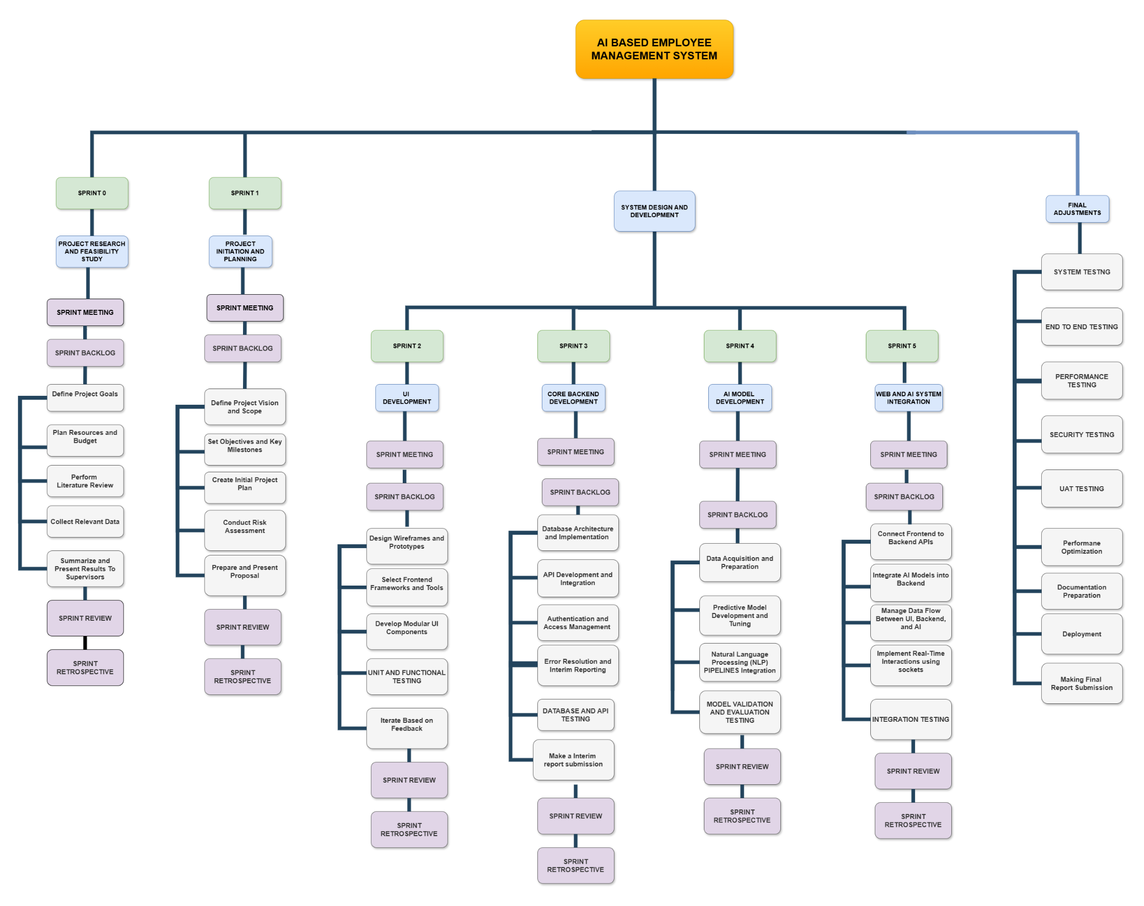

**8. MILESTONES:**

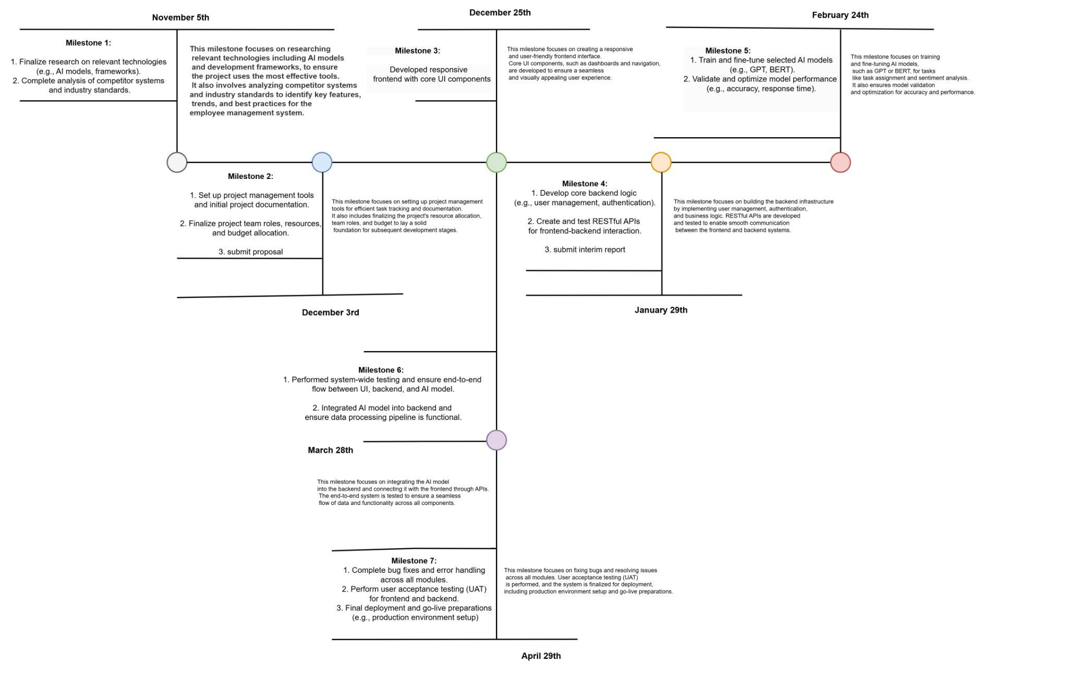

9. GANTT CHART:

10. CONCLUSION

This project aims to implement advanced AI-driven features while addressing potential risks and threats proactively. With robust contingency plans in place, such as thorough testing, employee training, data security measures, and continuous system updates, the project is well-positioned for success. By focusing on innovation, compliance, and user-friendly design, this initiative will enhance productivity and deliver a reliable, efficient employee management system.

11. BIBLIOGRAPHY: